

**Daily Market Intelligence**

**Models are Bearish Indices**

***Stocks…***

**Spoo 100X3…**falling out of the cloud would be extremely bearish.

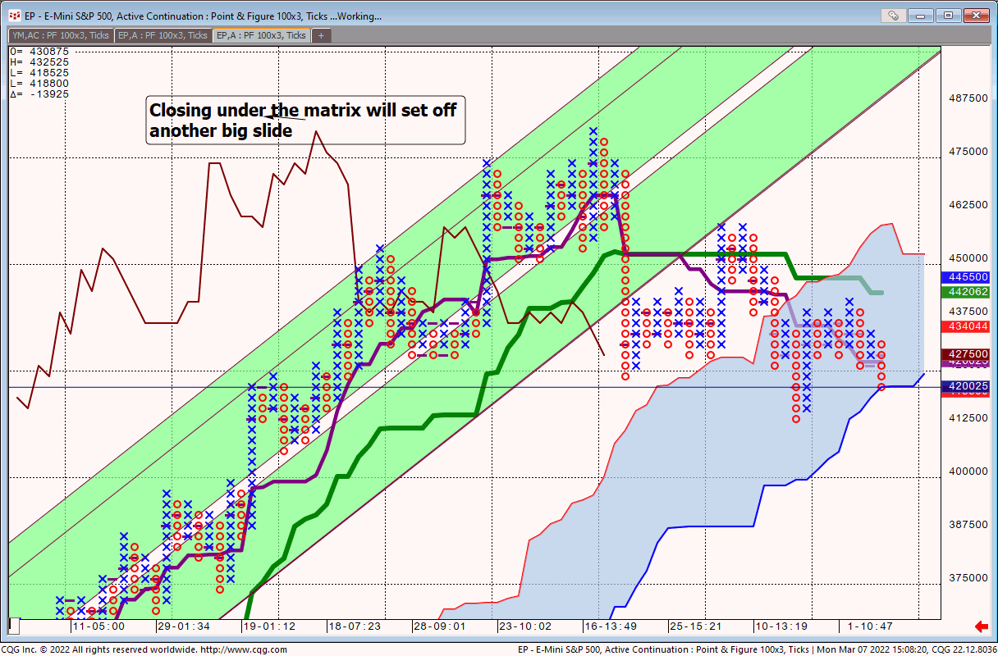

**Spoo/Bond…weekly**

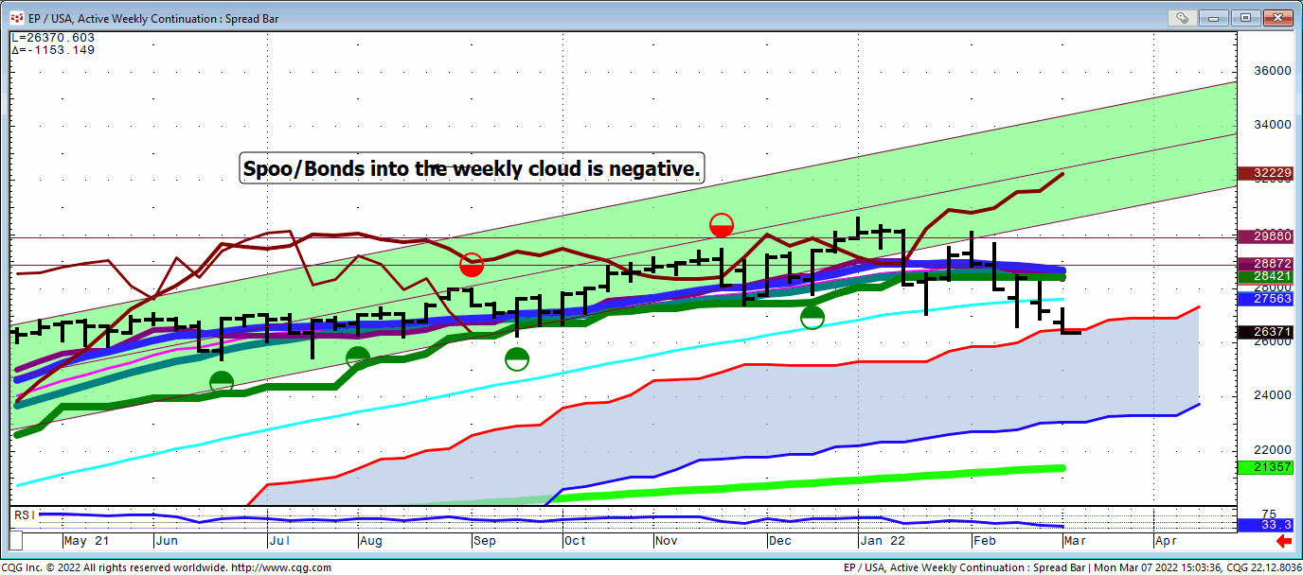

**Spoo/Bond Qtrly..**potential major topping pattern

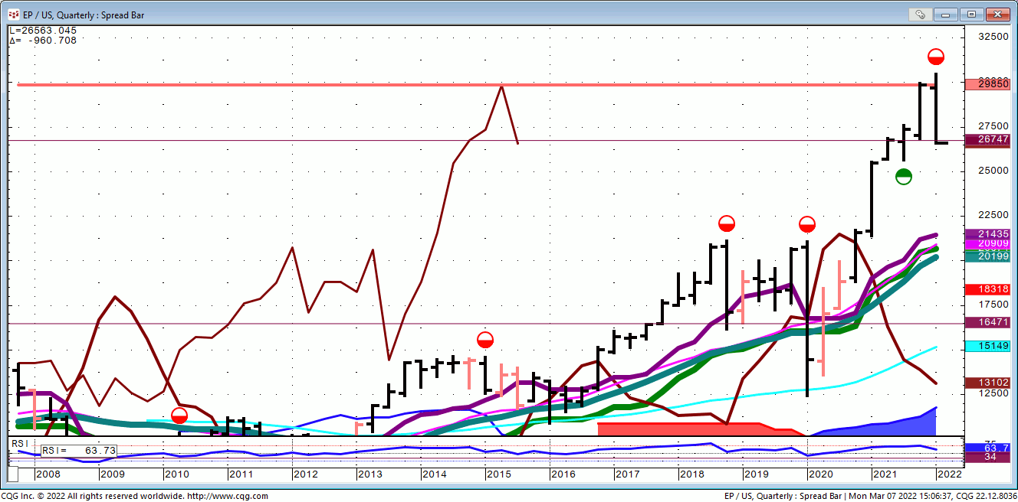

**Nasd/Bond…Qtrly**

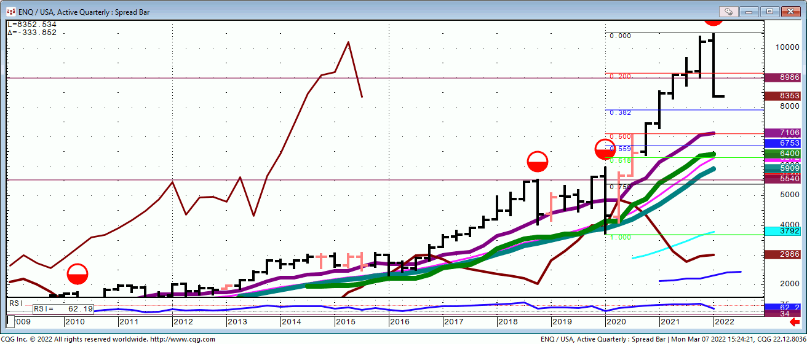

**GOOGL…**

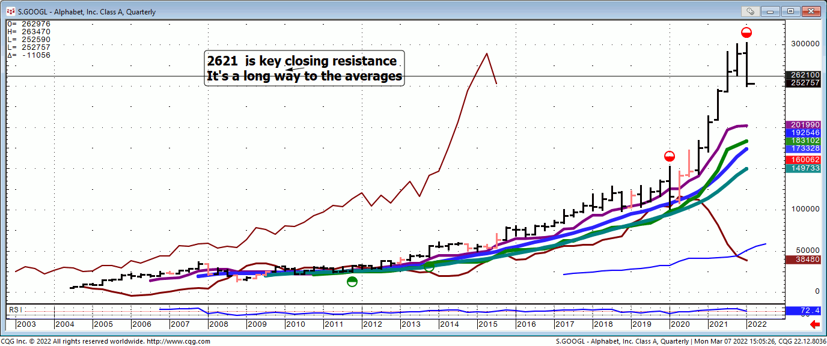

**FB…**

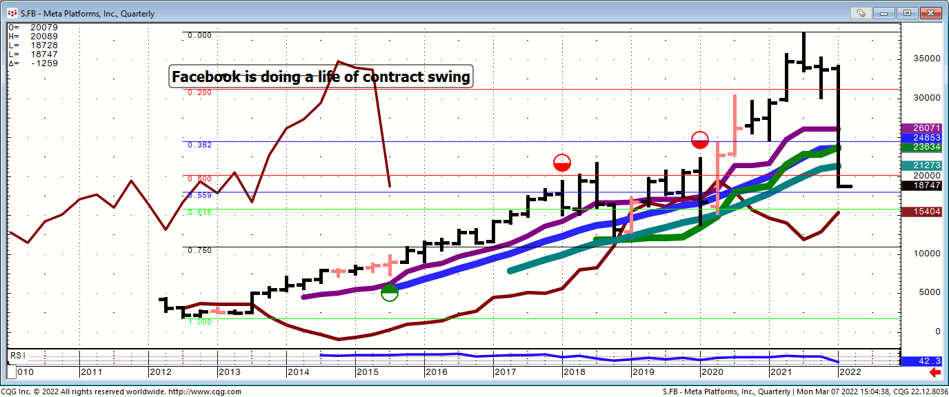

**KGC…**

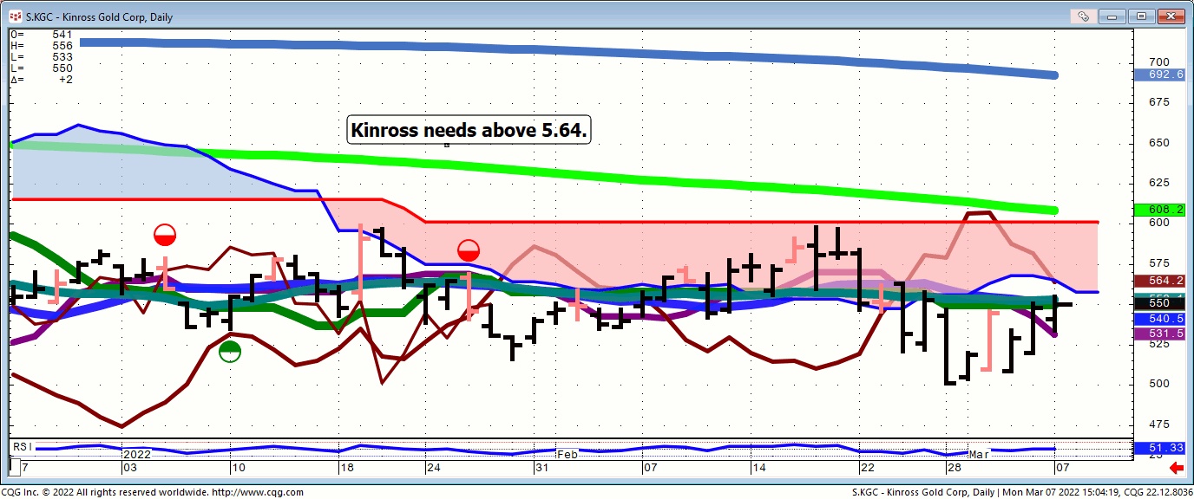

***Bond…***

***FX…***

**Bitcoin…Weekly**

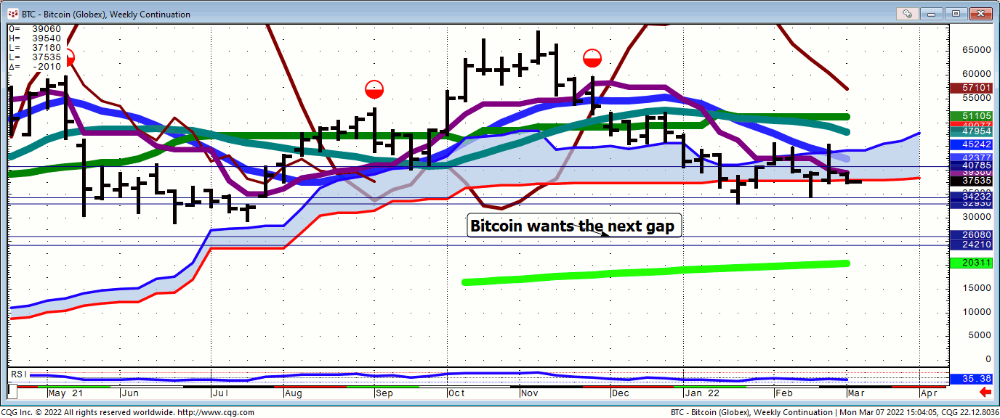

***Commodities…***

**Gold…100X3**

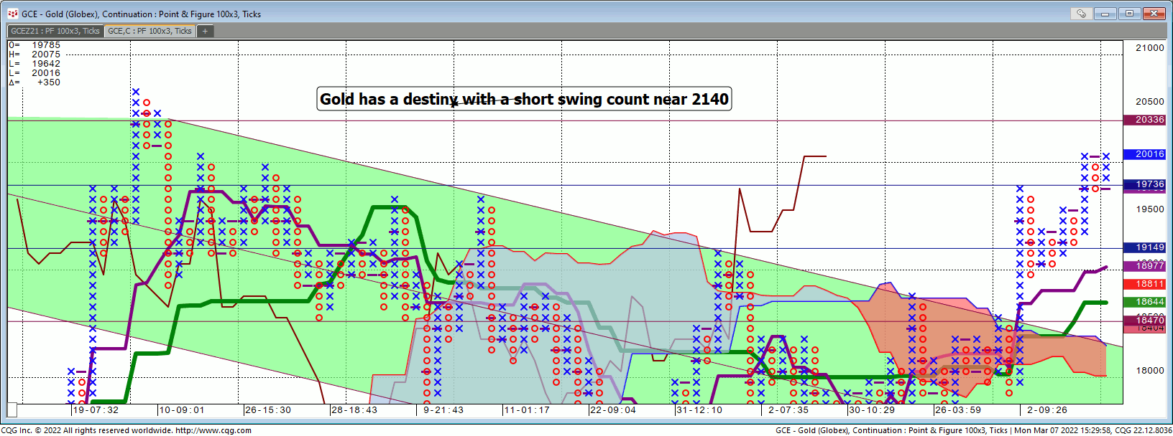

***General Comments or* Valuable Insight**

**The early part of the day was a giant weekly Pit gap fill.**

**Indices are trading on cease fire rumors.**

**The most brazen act of the day was the CBOT restricting new buyers in the Grains!**

**Ferucci, the Italian grain company, the same guys that were involved in the Russian Wheat deal, were squeezing CBOT members. “The Shorts”**

**The ban on buying created a break to let out the Shorts.**

**Free markets for Free Men!**

**As long as you’re the one making the rules!!!!**

**Look for Yra’s podcast to be posted soon.**

**The Roundtable Insight – Jacob Shapiro and Yra Harris on the Geo-Political Risks to the Economy and Financial Markets**

**Truer words were never uttered.**

**https://www.youtube.com/watch?v=pi6dVYinQt4**

**We Trade to Make Money**

**We don’t trade to be right**

**It is distance traveled not time in the trade!!!!!!!!!**

**Judd’s room is open.**

**Invites are sent before NYSE Opens.**

**I’ve started screen sharing just after 7 A.M.**

**CDT. I start speaking @ 8:20.**

**Please check your spam folder or your Google calendar if you don’t see an invite.**

**Not there? Just let me know in the A.M. to get one when the room opens.**

**W begin answering questions around 8:20 CDT.**

**I will review any instrument available on my platform and tell you what if anything I see**

**http://www.whitewavetradingstrategies.com/glossary/**

**WhiteWave Trading Strategies**

# Independent Research from the Pro’s Pro

# Chart Lines....Ichimoku

**Green Bright**...200 DMA **Aqua** 50 DMA **Blue**

**Green** 21 DMA **Fuchsia** 18 DMA  **Yellow** 10 SMA

These are simple moving averages. When you roll a chart to weekly or monthly the averages are simple weekly or monthly mvg averages.

The **reddish purple** is an embedded Imoku line which acts as momentum.

The **leaf green** is an embedded Imoku line which calculates 50% retraces.

**Brown line** is where the Macd with histogram crosses. The line shows the visual on every time frame so you don’t have to guess looking at the price of the cross in a line study.

